**DIGITAL SIGNAL PROCESSING LAB EXPT.4**

**NIKHIL ROUT**

**22BEC1020**

**AIM: To Design and Perform the Characteristic Analysis of Low Pass, High Pass, Band Pass & Band Stop Filters with Butterworth, Chebyshev – I and Chebyshev – II type of Frequency Responses / Analysis with Varying Orders**

**LOW PASS**

clc

close all

clear all

fc1=1500;

fc2=1500;

fs=8000;

n1=2;

n2=5;

n3=10;

rp=1;

rs=20;

[b1,a1]=butter(n1,2*fc1/fs,'low');

[b2,a2]=cheby1(n2,rp,2*fc1/fs,'low');

[b3,a3]=cheby2(n3,rs,2*fc1/fs,'low');

w=0:0.1:pi;

[h1,o1]=freqz(b1,a1,w);

m1=abs(h1);

[h2,o2]=freqz(b2,a2,w);

m2=abs(h2);

[h3,o3]=freqz(b3,a3,w);

m3=abs(h3);

subplot(2,2,1);

plot(o1/pi*fs/2,m1,'linewidth',2);

set(gca,'fontsize',13,'fontweight','bold');

title(['Butterworth Low Pass Filter Response (order=', num2str(n1),')'],'fontsize',14,'fontweight','bold');

xlabel('Frequency (Hz)','fontsize',14,'fontweight','bold');

ylabel('Magnitude','fontsize',14,'fontweight','bold');

grid on;

subplot(2,2,2);

plot(o2/pi*fs/2,m2,'linewidth',2);

set(gca,'fontsize',13,'fontweight','bold');

title(['Chebyshev-1 Low Pass Filter Response (order=', num2str(n1),')'],'fontsize',14,'fontweight','bold');

xlabel('Frequency (Hz)','fontsize',14,'fontweight','bold');

ylabel('Magnitude','fontsize',14,'fontweight','bold');

grid on;

subplot(2,2,3);

plot(o3/pi*fs/2,m3,'linewidth',2);

set(gca,'fontsize',13,'fontweight','bold');

title(['Chebyshev-2 Low Pass Filter Response (order=', num2str(n1),')'],'fontsize',14,'fontweight','bold');

xlabel('Frequency (Hz)','fontsize',14,'fontweight','bold');

ylabel('Magnitude','fontsize',14,'fontweight','bold');

grid on;

subplot(2,2,4);

plot(o3/pi*fs/2,m1,'linewidth',2);

set(gca,'fontsize',13,'fontweight','bold');

title(['Different Butterworth Low Pass Filter Response (order=', num2str(n1),')'],'fontsize',14,'fontweight','bold');

xlabel('Frequency (Hz)','fontsize',14,'fontweight','bold');

ylabel('Magnitude','fontsize',14,'fontweight','bold');

grid on;

hold on;

plot(o3/pi*fs/2,m2,'linewidth',2);

hold on;

plot(o3/pi*fs/2,m3,'linewidth',2);

hold on;

legend(['order= ',num2str(n1)]',['order= ',num2str(n2)]',['order= ',num2str(n3)]');

grid on;

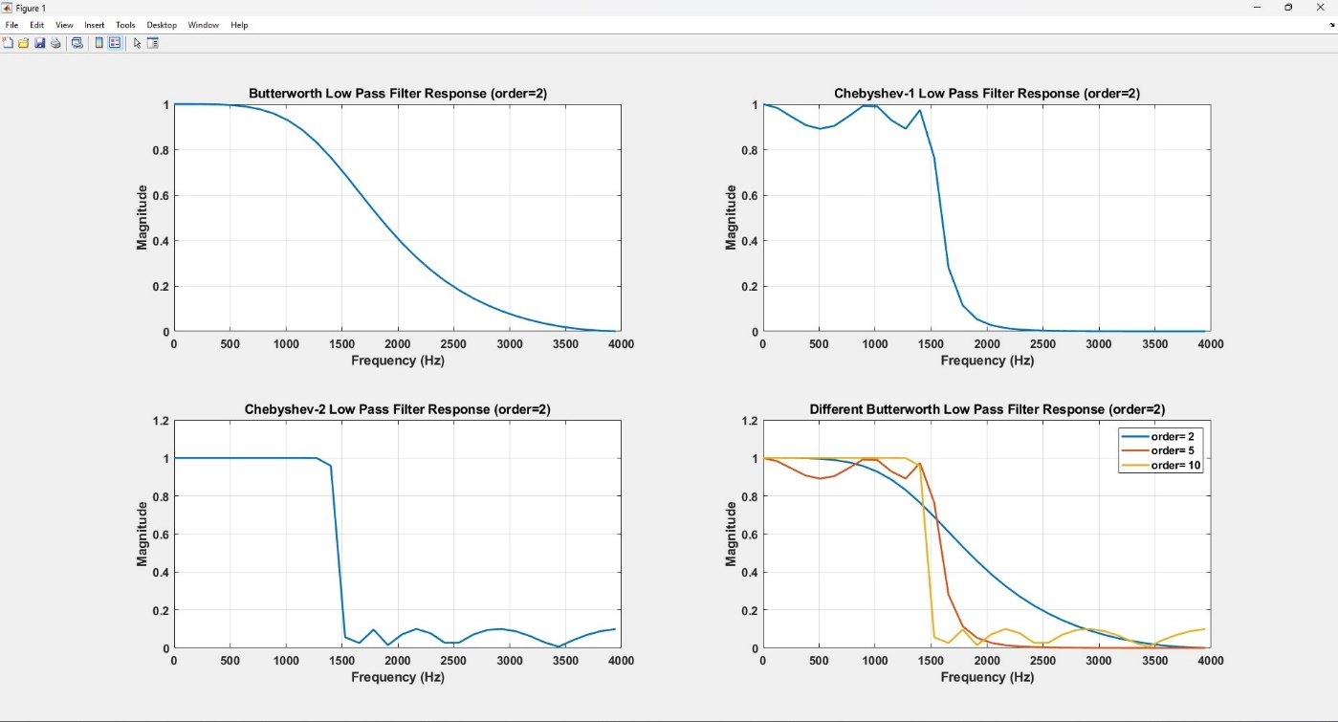

**HIGH PASS**

clc

close all

clear all

fc1=1500;

fc2=1500;

fs=8000;

n1=2;

n2=5;

n3=10;

rp=1;

rs=20;

[b1,a1]=butter(n1,2*fc1/fs,'high');

[b2,a2]=cheby1(n2,rp,2*fc1/fs,'high');

[b3,a3]=cheby2(n3,rs,2*fc1/fs,'high');

w=0:0.1:pi;

[h1,o1]=freqz(b1,a1,w);

m1=abs(h1);

[h2,o2]=freqz(b2,a2,w);

m2=abs(h2);

[h3,o3]=freqz(b3,a3,w);

m3=abs(h3);

subplot(2,2,1);

plot(o1/pi*fs/2,m1,'linewidth',2);

set(gca,'fontsize',13,'fontweight','bold');

title(['Butterworth High Pass Filter Response (order=', num2str(n1),')'],'fontsize',14,'fontweight','bold');

xlabel('Frequency (Hz)','fontsize',14,'fontweight','bold');

ylabel('Magnitude','fontsize',14,'fontweight','bold');

grid on;

subplot(2,2,2);

plot(o2/pi*fs/2,m2,'linewidth',2);

set(gca,'fontsize',13,'fontweight','bold');

title(['Chebyshev-1 High Pass Filter Response (order=', num2str(n1),')'],'fontsize',14,'fontweight','bold');

xlabel('Frequency (Hz)','fontsize',14,'fontweight','bold');

ylabel('Magnitude','fontsize',14,'fontweight','bold');

grid on;

subplot(2,2,3);

plot(o3/pi*fs/2,m3,'linewidth',2);

set(gca,'fontsize',13,'fontweight','bold');

title(['Chebyshev-2 High Pass Filter Response (order=', num2str(n1),')'],'fontsize',14,'fontweight','bold');

xlabel('Frequency (Hz)','fontsize',14,'fontweight','bold');

ylabel('Magnitude','fontsize',14,'fontweight','bold');

grid on;

subplot(2,2,4);

plot(o3/pi*fs/2,m1,'linewidth',2);

set(gca,'fontsize',13,'fontweight','bold');

title(['Different Butterworth High Pass Filter Response (order=', num2str(n1),')'],'fontsize',14,'fontweight','bold');

xlabel('Frequency (Hz)','fontsize',14,'fontweight','bold');

ylabel('Magnitude','fontsize',14,'fontweight','bold');

grid on;

hold on;

plot(o3/pi*fs/2,m2,'linewidth',2);

hold on;

plot(o3/pi*fs/2,m3,'linewidth',2);

hold on;

legend(['order= ',num2str(n1)]',['order= ',num2str(n2)]',['order= ',num2str(n3)]');

grid on;

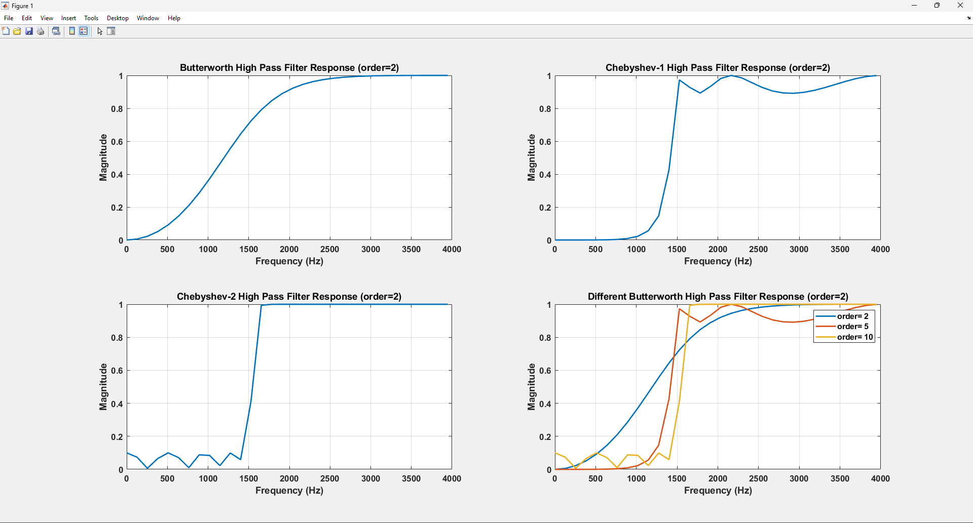

**BANDPASS FILTER**

clc

clear all

close all

fc1=1500;

fc2=500;

fs=8000;

n1=2;

n2=5;

n3=10;

rp=1;

rs=20;

wn=[2*fc1/fs 2*fc2/fs];

[b1,a1]=butter(n1,wn,'bandpass');

[b2,a2]=cheby1(n2,rp,wn,'bandpass');

[b3,a3]=cheby2(n3,rs,wn,'bandpass');

w=0:0.01:pi;

[h1,o1]=freqz(b1,a1,w);

m1=abs(h1);

[h2,o2]=freqz(b2,a2,w);

m2=abs(h2);

[h3,o3]=freqz(b3,a3,w);

m3=abs(h3);

subplot(2,2,1);

plot(o1/pi*fs/2,m1 ,'linewidth',2);

set(gca,'fontsize',13,'fontweight','bold');

title(['Butterworth Band Pass Filter Response(Order=',num2str(n1),')'],'fontsize',14);

ylabel('Magnitude','fontsize',12,'fontweight','bold');

xlabel('Frequency(Hz)','fontsize',12,'fontweight','bold');

grid on;

subplot(2,2,2);

plot(o2/pi*fs/2,m2 ,'linewidth',2);

set(gca,'fontsize',13,'fontweight','bold');

title(['Chebyshev-1 Band Pass Filter Response(Order=',num2str(n2),')'],'fontsize',14);

ylabel('Magnitude','fontsize',12,'fontweight','bold');

xlabel('Frequency(Hz)','fontsize',12,'fontweight','bold');

grid on;

subplot(2,2,3);

plot(o3/pi*fs/2,m3 ,'linewidth',2);

set(gca,'fontsize',13,'fontweight','bold');

title(['Chebyshev-2 Band Pass Filter Response(Order=',num2str(n3),')'],'fontsize',14);

ylabel('Magnitude','fontsize',12,'fontweight','bold');

xlabel('Frequency(Hz)','fontsize',12,'fontweight','bold');

grid on;

subplot(2,2,4);

plot(o3/pi*fs/2,m1 ,'linewidth',2);

set(gca,'fontsize',13,'fontweight','bold');

title(['Butterworth Band Pass Filter Response for different Orders'],'fontsize',14);

ylabel('Magnitude','fontsize',12,'fontweight','bold');

xlabel('Frequency(Hz)','fontsize',12,'fontweight','bold');

grid on

hold on;

plot(o3/pi*fs/2,m2 ,'linewidth',2);

hold on;

plot(o3/pi*fs/2,m3 ,'linewidth',2);

hold on;

legend(['Order = ',num2str(n1)],['Order = ',num2str(n2)], ['Order = ',num2str(n3)]);

grid on;

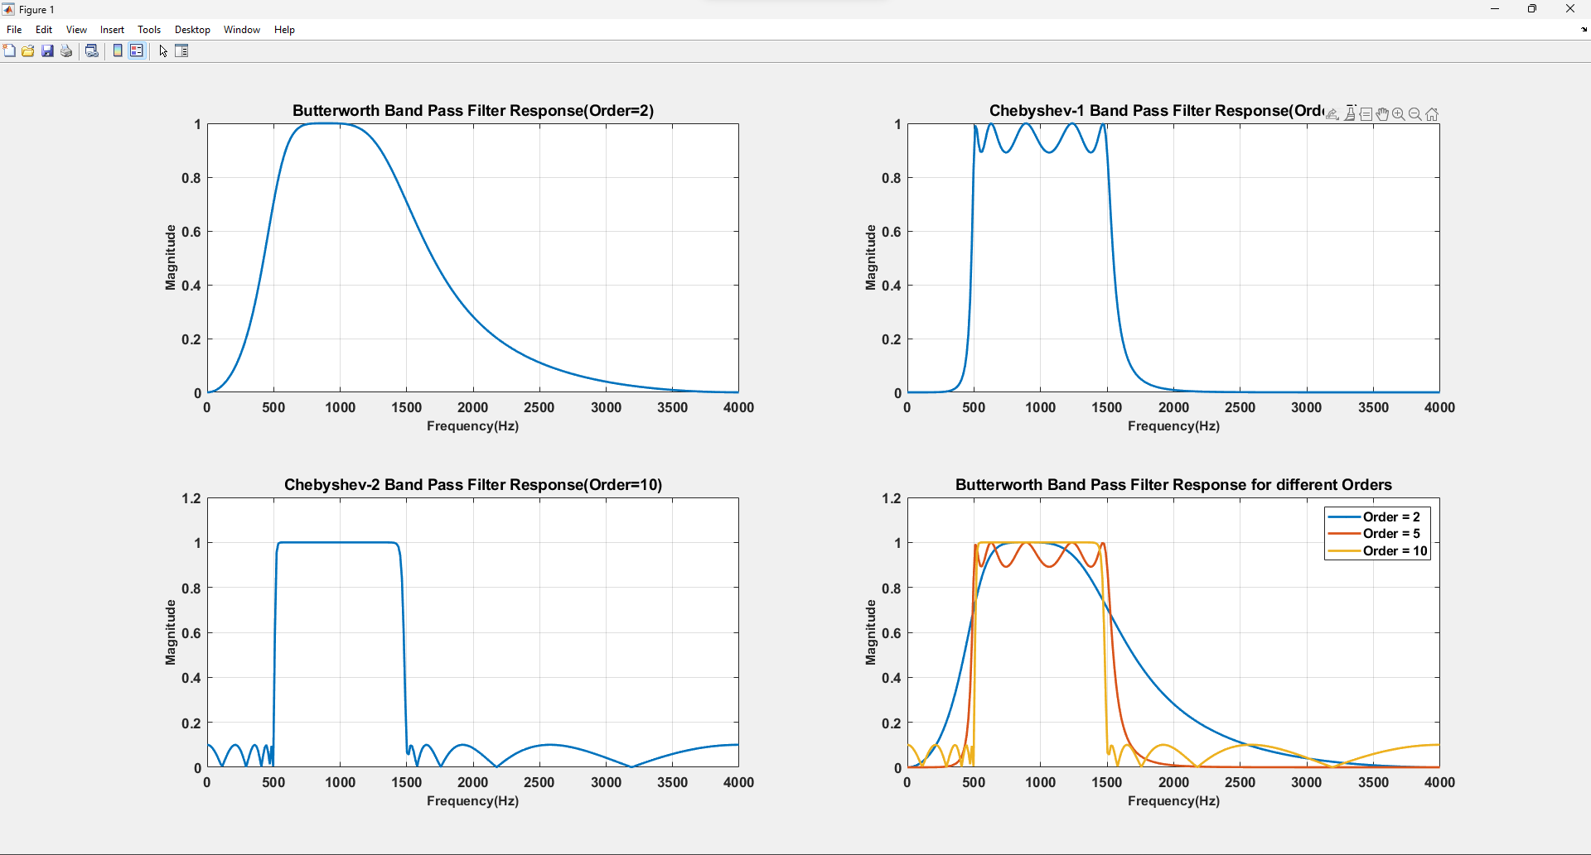

**BANDSTOP FILTER**

clc

clear all

close all

fc1 = 1500;

fc2 = 500;

fs = 8000;

n1 = 2;

n2 = 5;

n3 = 10;

rp = 1;

rs = 20;

wn = [2*fc1/fs 2*fc2/fs];

[b1, a1] = butter(n1, wn, 'stop');

[b2, a2] = cheby1(n2, rp, wn, 'stop');

[b3, a3] = cheby2(n3, rs, wn, 'stop');

w = 0:0.1:pi;

[h1, om1] = freqz(b1, a1, w);

m1 = abs(h1);

[h2, om2] = freqz(b2, a2, w);

m2 = abs(h2);

[h3, om3] = freqz(b3, a3, w);

m3 = abs(h3);

subplot(2,2,1);

plot(om1/pi*fs/2, m1, 'linewidth',2);

title(['Butterworth Bandstop (order ' num2str(n1) ')'], 'fontsize', 14);

xlabel('Frequency (Hz)', 'fontsize', 14);

ylabel('Magnitude', 'fontsize', 14);

grid on;

subplot(2,2,2);

plot(om2/pi*fs/2, m2, 'linewidth',2);

title(['Chebyshev Type 1 (order ' num2str(n2) ')'], 'fontsize', 14);

xlabel('Frequency (Hz)', 'fontsize', 14);

ylabel('Magnitude', 'fontsize', 14);

grid on;

subplot(2,2,3);

plot(om3/pi*fs/2, m3, 'linewidth',2);

title(['Chebyshev Type 2 (order ' num2str(n3) ')'], 'fontsize', 14);

xlabel('Frequency (Hz)', 'fontsize', 14);

ylabel('Magnitude', 'fontsize', 14);

grid on;

subplot(2,2,4);

hold on;

plot(om3/pi*fs/2, m1, 'linewidth',2);

plot(om3/pi*fs/2, m2, 'linewidth',2);

plot(om3/pi*fs/2, m3, 'linewidth',2);

legend(['order ' num2str(n1)], ['order ' num2str(n2)], ['order ' num2str(n3)]);

xlabel('Frequency (Hz)', 'fontsize', 14);

ylabel('Magnitude', 'fontsize', 14);

grid on;

hold off;

